CatholicLibrary.org Templates for Catholic Schools

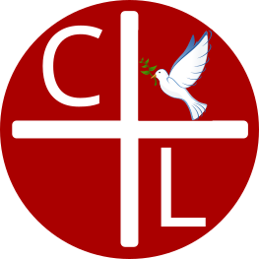 | CatholicLibrary.org is a free online resource with thousands of Catholic books in original language, English, and dual texts. It includes many books included in Great Books curriculums, Fathers, Doctors, Magisterium, a special interlinear Scripture section, and a beautiful Catholic art gallery. Take a look and enjoy!

CatholicLibrary.org is a free online resource with thousands of Catholic books in original language, English, and dual texts. It includes many books included in Great Books curriculums, Fathers, Doctors, Magisterium, a special interlinear Scripture section, and a beautiful Catholic art gallery. Take a look and enjoy!

CatholicLibrary.org is a free online resource with thousands of Catholic books in original language, English, and dual texts. It includes many books included in Great Books curriculums, Fathers, Doctors, Magisterium, a special interlinear Scripture section, and a beautiful Catholic art gallery. Take a look and enjoy!

CatholicLibrary.org is a free online resource with thousands of Catholic books in original language, English, and dual texts. It includes many books included in Great Books curriculums, Fathers, Doctors, Magisterium, a special interlinear Scripture section, and a beautiful Catholic art gallery. Take a look and enjoy!

