CatholicLibrary.org Templates for Catholic Parishes

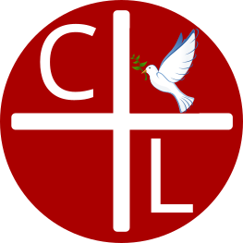 | CatholicLibrary.org is a free online resource with thousands of Catholic books from the Fathers, Doctors, Magisterium, and more. Books are English, dual text, and original language. It has a special Scripture section and a beautiful Catholic art gallery. Take a look and enjoy!

CatholicLibrary.org is a free online resource with thousands of Catholic books from the Fathers, Doctors, Magisterium, and more. Books are English, dual text, and original language. It has a special Scripture section and a beautiful Catholic art gallery. Take a look and enjoy!

CatholicLibrary.org is a free online resource with thousands of Catholic books from the Fathers, Doctors, Magisterium, and more. Books are English, dual text, and original language. It has a special Scripture section and a beautiful Catholic art gallery. Take a look and enjoy!

CatholicLibrary.org is a free online resource with thousands of Catholic books from the Fathers, Doctors, Magisterium, and more. Books are English, dual text, and original language. It has a special Scripture section and a beautiful Catholic art gallery. Take a look and enjoy!

